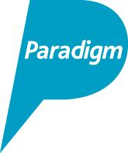
PARADIGM HOUSING GROUP STRUCTURE
Ownership
Control
Key:

Paradigm Development
Services Limited
Paradigm Homes Charitable
Housing Association Limited
Paradigm Housing Group Limited

Paradigm Maintenance
Limited

Paradigm Commercial Limited

